Pointers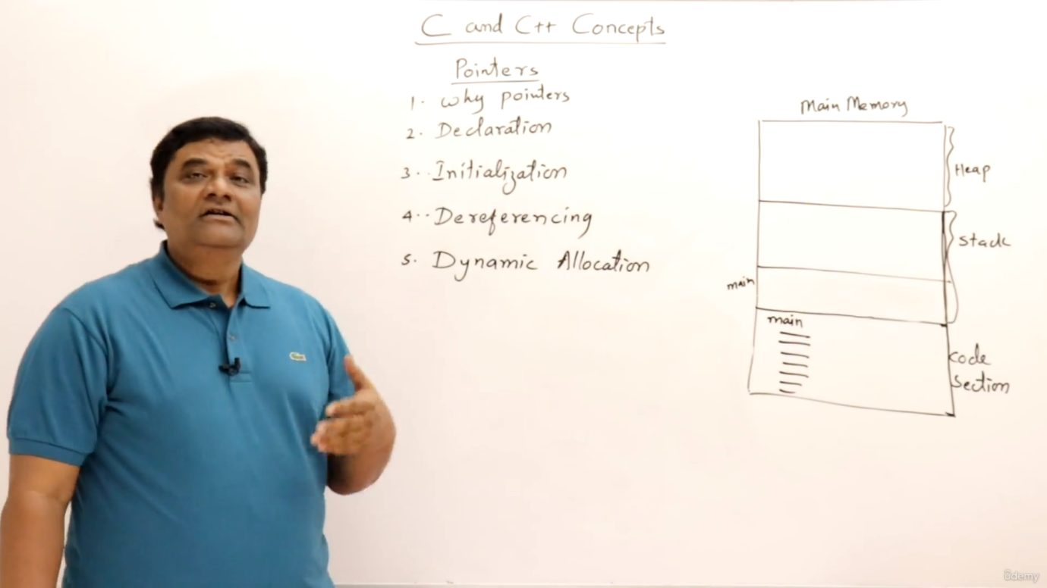

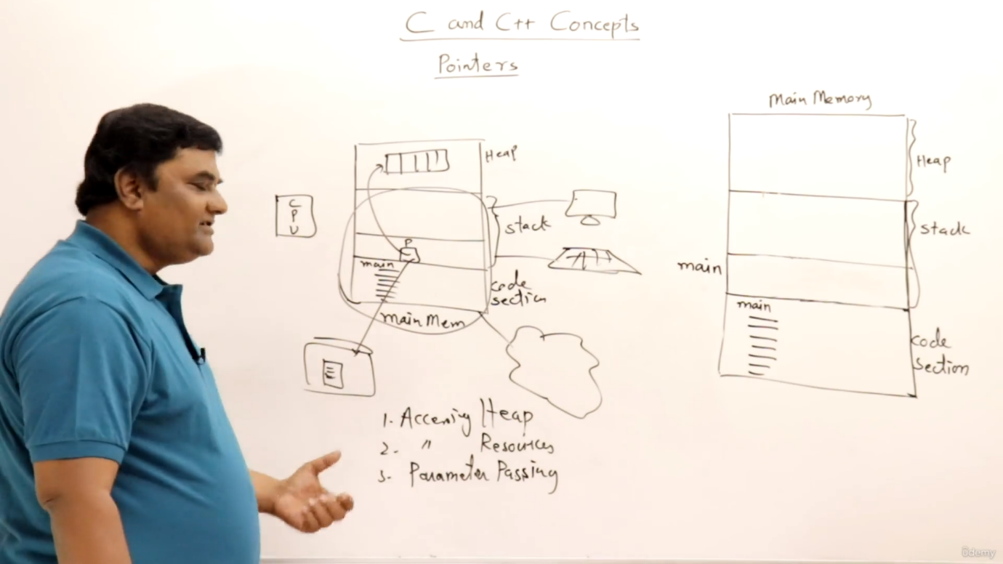

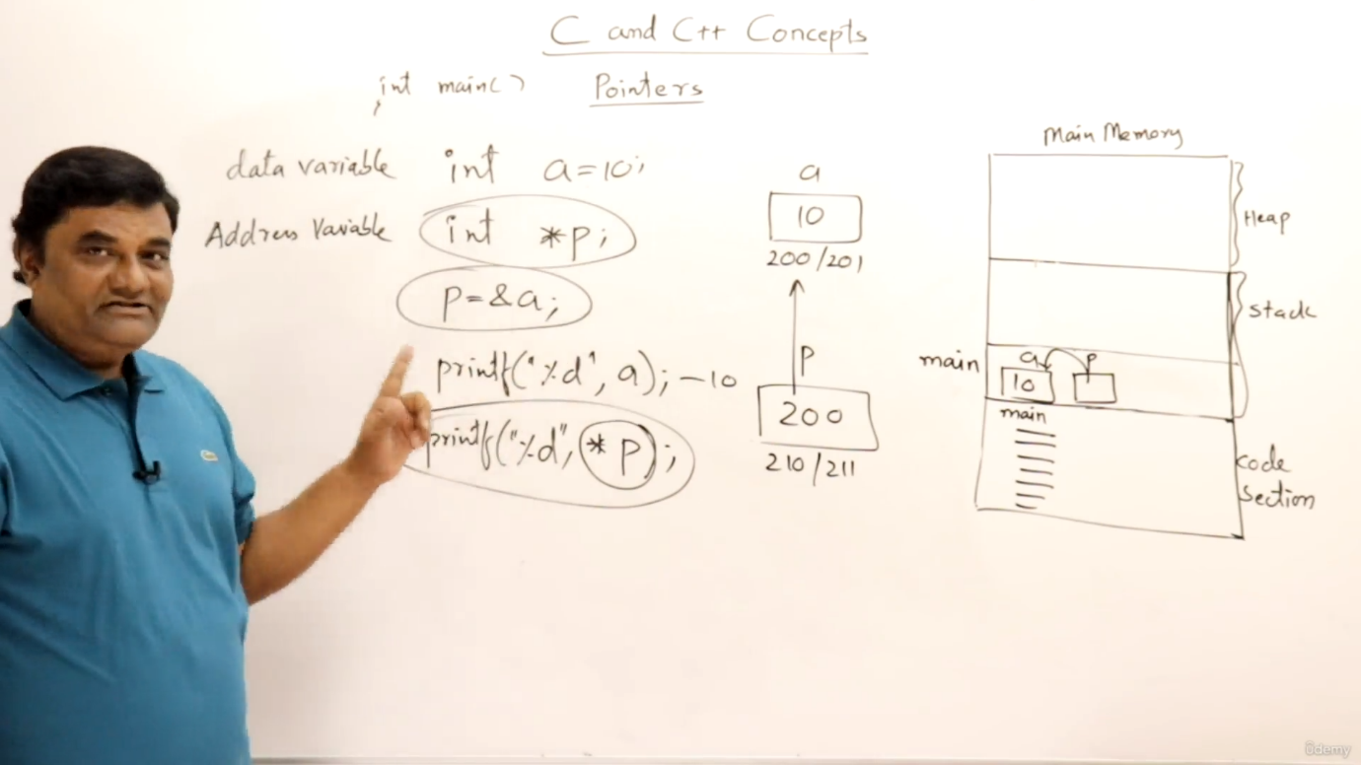

Here I am not accessing a heap memory now we will access it ,here we are just accessing a thing which is in stack as is it is declared by us

How do I get the heap memory by using malloc function.

Using malloc function we get a memory and then we type cast it to a variable.

